**LAB 2**

1.

package com.company;  
import java.util.Scanner;  
  
public class Main {  
 public static void main(String[] args) {  
 Scanner n = new Scanner(System.*in*);  
 int n1, n2;  
 n1 = n.nextInt();  
 n2 = n.nextInt();  
 int res = *gcd1*(n1, n2);  
 System.*out*.println("The GCD is "+res);  
 }  
  
 public static int gcd1(int n1, int n2) {  
 int gcd=1;  
 for(int i = 1; i <= n1 && i <= n2; ++i)  
 {  
   
 if(n1 % i==0 && n2 % i==0)  
 gcd = i;  
 }  
 return gcd;  
 }  
}

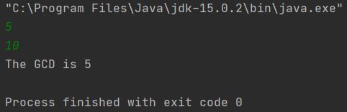

2.

package com.company;  
import java.util.Scanner;  
import static java.lang.Math.*pow*;  
class ticket{  
 public boolean isValidTicket(long a){  
 String s = String.*valueOf*(a);  
 long ldig,b;  
 if(s.length()==11)  
 {  
 ldig=a%10;  
 b=a/10;  
 if((b%7)==ldig)  
 return true;  
 else  
 return false;  
  
 }  
 else if(s.length()==10)  
 {  
 ldig=a%7;  
 a=(a*10)+ldig;  
 System.*out*.println(a);  
 return true;  
 }  
 else{  
 return false;  
 }  
 }  
}  
public class Main  
{  
 public static void main(String[] args) {  
 ticket T = new ticket();  
 Scanner in = new Scanner(System.*in*);  
 long inp = in.nextLong();  
 boolean ans = T.isValidTicket(inp);  
 if(ans)  
 System.*out*.println("Valid");  
 else  
 System.*out*.println("Invalid");  
 }  
}

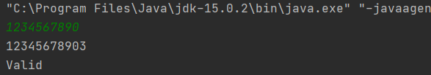

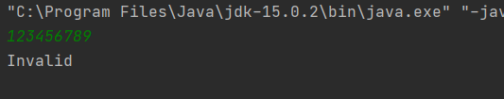

3.

package com.company;  
import java.lang.String;  
import java.util.Scanner;  
public class Main {  
 public static String reversestring(String S)  
 {  
 StringBuilder S1 = new StringBuilder();  
 S1.append(S);  
 S1.reverse();  
 return S1.toString();  
 }  
 public static boolean isPalindrome(String S)  
 {  
 if(S.length()>2) {  
 String S1 = *reversestring*(S);  
 return S.equals(S1);  
 }  
 return false;  
 }  
 public static void main(String[] args) {  
 int count=0;  
 Scanner in = new Scanner(System.*in*);  
 String line = in.nextLine();  
 String[] arr = line.split(" ");  
 for(int i=0;i<arr.length;i++)  
 {  
 if(*isPalindrome*(arr[i]))  
 {  
 System.*out*.println(arr[i]);  
 count++;  
 }  
 }  
 System.*out*.println(count);  
 }  
}

